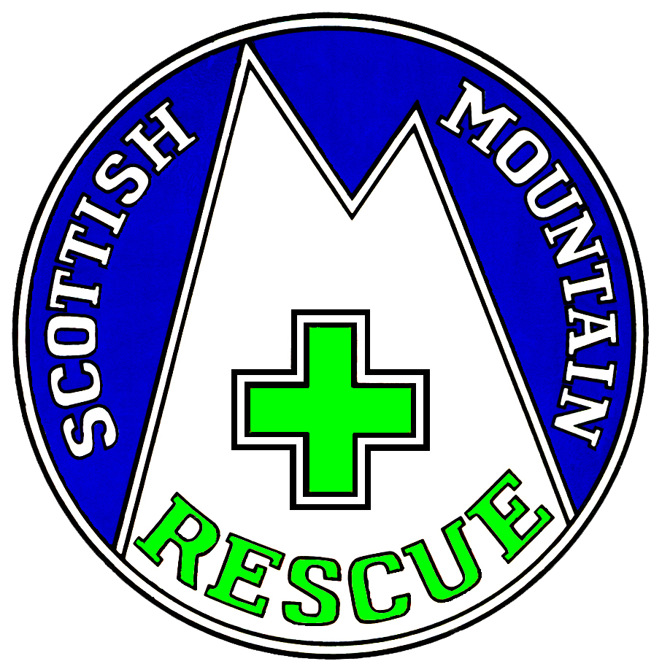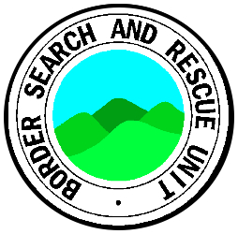
Borders Search and Rescue Unit

The team had its first Coronavirus era call out on the evening of the 4th of May, to assist at a quad bike accident. As indicated in a previous contribution a limited response was activated. Four team members and 1 vehicle attended but were not needed as a Scottish Ambulance SORT crew (Special Operations Response Team) had arrived on scene as well as the usual ambulance. In hospital it was ascertained the casualty did not sustain any serious injuries.

History

Mountain Rescue teams can call on the assistance of a rescue helicopter in the event of a critical casualty to expedite transfer of the person to hospital. This service is weather dependent as extremely strong wind conditions or fog may prevent helicopters from flying. Night vision goggles enable helicopters to be flown at night.
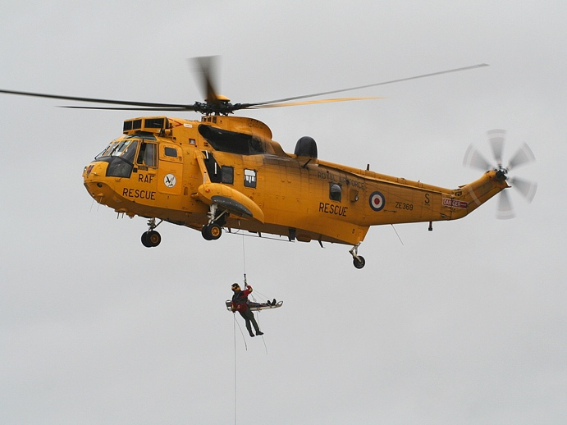
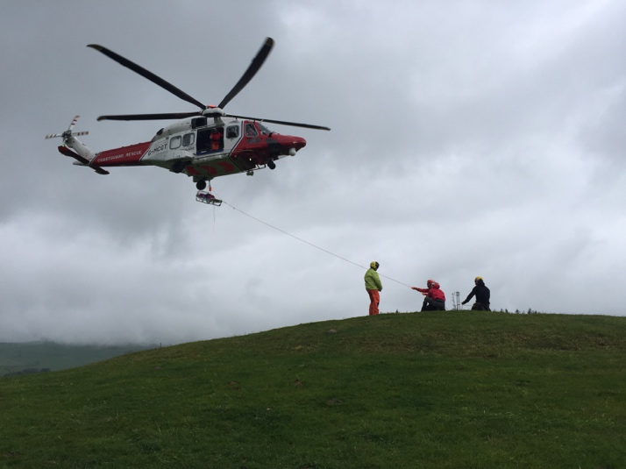

Until 2015 helicopter rescue was provided by the Royal Airforce (yellow Sea King helicopters) and the Royal Navy (red and grey helicopters). Helicopters from RAF Boulmer tended to be the option available to BSARU.

In 2015 Bristow Helicopters, under a 10 year contract, assumed responsibility for search and rescue operations within the UK on behalf of HM Coastguard. New helicopters in a red and white Coast Guard livery came into operation.

Protective Kit

Scottish Mountain Rescue with the help of the Scottish Government and Police Scotland managed to get FFP2 face masks donated by Apple and these have been distributed to the teams and team members. Prior to these the team had ordered 20 from another source along with gloves which were ordered some time ago. Down draught from helicopters can cause loose debris/dust to fly around and team members have googles to protect their eyes. The googles now have a further use.

Sad News

The team was saddened to hear of the death recently of former BSARU team leader Ernie Blood. Ernie was a team member from the 60s to the late 70s. More about Ernie can be read on the team’s facebook page.

https://www.scottishmountainrescue.org and http://www.bordersar.org.uk
BSARU is a Scottish Charitable Incorporated Organisation SCO23213

Seymour Haugh

